GitHub: <https://github.com/sandy100061/MachineLearningAssignment/tree/main/Assignment1>

Video Link:

**Question 1**

**The following is a list of 10 students’ ages:**

ages = [19, 22, 19, 24, 20, 25, 26, 24, 25, 24]

* Sort the list and find the min and max age
* Add the min age and the max-age again to the list
* Find the median age (one middle item or two middle items divided by two)
* Find the average age (sum of all items divided by their number)
* Find the range of the ages (max minus min)

# Sorting the list and find the min and max age

ages = [19, 22, 19, 24, 20, 25, 26, 24, 25, 24]

ages.sort()

print(f'Sorted Array : {ages}')

minAge = min(ages)

maxAge = max(ages)

# min and max-age

print(f'Minimum val: {minAge}')

print(f'Maximum val: {maxAge}')

# Add the min age again to the list

ages.append(minAge)

print(ages)

# Add the max-age again to the list

ages.append(maxAge)

print(ages)

# Calculation of Median using statics library

import statistics

print(f'MedianAge : {statistics.median(ages)}')

# Calculation of Average value

average= sum(ages)/len(ages)

print(f'Average is {average}')

**Question 2**

* Create an empty dictionary called a dog.
* Add name, color, breed, legs, and age to the dog dictionary
* Create a student dictionary and add first_name, last_name, gender, age, marital status, skills, country, city, and address as keys for the dictionary
* Get the length of the student dictionary
* Get the value of skills and check the data type; it should be a list
* Modify the skills values by adding one or two skills
* Get the dictionary keys as a list
* Get the dictionary values as a list

# Create an empty dictionary called dog.

dog = {}

# Add name, color, breed, legs, age to the dog dictionary

print('Adding name, color, breed, legs, age to the dog dictionary')

dog['name'] = 'Daisy'

dog['color'] = 'Black'

dog['breed'] = 'Labrador Retriever'

dog['legs'] = 4

dog['age'] = 14

# Create a student dictionary and add first_name, last_name, gender, age, marital status, skills, country, city and address as keys for the dictionary

print('Creating Empty Student Dictionary and Adding first_name, last_name, gender, age, marital status, skills, country, city and address as keys')

student = {}

student['first_name'] = 'Sandeep'

student['last_name'] = 'Yadav'

student['gender'] = 'Male'

student['age'] = 31

student['marital_status'] = 'Single'

student['skills'] = ['Python', 'Java', 'DotNet', 'CSS']

student['country'] = 'USA'

student['city'] = 'Kansas'

student['address'] = '106th St'

# Get the length of the student dictionary

studentLen = len(student)

print(f'Student Dictionary Length is {studentLen}')

#Get the value of skills and check the data type, it should be a list

skills = student['skills']

print(f'value of skills {skills}')

print(f'Datatype of skills is {type(skills)}')

# Modify the skills values by adding one or two skills

skills.append('Angular')

skills.append('SQL')

print(f'Student Skills : {student["skills"]}')

#Get the dictionary keys as a list

keys = list(student)

print('Student Dictionary Keys:')

print(f'{keys}')

# Get the dictionary values as a list

values = list(student.values())

print('Student Dictionary Values:')

print(f'{values}')

**Question 3**

* Create a tuple containing the names of your sisters and your brothers (imaginary siblings are fine)
* Join brothers and sisters’ tuples and assign it to siblings.
* How many siblings do you have?
* Modify the sibling’s tuple and add the name of your father and mother and assign it to family_members

#Create a tuple containing names of your sisters and your brothers (imaginary siblings are fine)

mySisters = ('Anupriya', 'Arya','Aayat','Shweta')

myBrothers = ('Ankit','Alok','Abhinav','Aryman','Aditya')

print('My sister names are : ', mySisters)

print('My brother names are : ', myBrothers)

# Join brothers and sisters tuples and assign it to siblings

siblings = myBrothers + mySisters

print('All siblings are:', siblings)

# How many siblings do you have?

print("Number of Siblings:", len(siblings))

family_members = siblings + ('Rambilash Rai', 'Geeta Rai')

print('All faimly members are:', family_members)

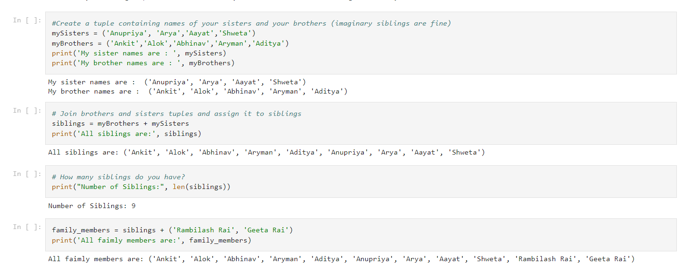

**Question 4**

it_companies = {'Facebook', 'Google', 'Microsoft', 'Apple', 'IBM', 'Oracle', 'Amazon'}

A = {19, 22, 24, 20, 25, 26}

B = {19, 22, 20, 25, 26, 24, 28, 27}

age = [22, 19, 24, 25, 26, 24, 25, 24]

* Find the length of the set it_companies
* Add 'Twitter' to it_companies
* Insert multiple IT companies at once to the set it_companies
* Remove one of the companies from the set it_companies
* What is the difference between remove and discard
* Join A and B
* Find A intersection B
* Is A subset of B
* Are A and B disjoint sets
* Join A with B and B with A
* What is the symmetric difference between A and B
* Delete the sets completely
* Convert the ages to a set and compare the length of the list and the set

#Find the length of the set it_companies

it_companies = {'Facebook', 'Google', 'Microsoft', 'Apple', 'IBM', 'Oracle', 'Amazon'}

print("Length of IT Companies:", len(it_companies))

#Add 'Twitter' to it_companies

it_companies.add('Twitter')

print("After adding Twitter", it_companies)

#Insert multiple IT companies at once to the set it_companies

it_companies.update({'AIS', 'Infosys','Capgemini','Wipro','TCS'})

print("After adding multiple companies:",it_companies)

#Remove one of the companies from the set it_companies

it_companies.remove('Capgemini')

print("After removing one company:",it_companies)

#What is the difference between remove and discard

#Discard doesn't raise any error if any item is not present in the set

it_companies.discard('TCS')

print("After discarding company:",it_companies)

A = {19, 22, 24, 20, 25, 26}

B = {19, 22, 20, 25, 26, 24, 28, 27}

age = [22, 19, 24, 25, 26, 24, 25, 24]

#Join A and B

print("Join A and B:", A.union(B))

#Find A intersection B

print("Intersection of A and B:", A.intersection(B))

#Is A subset of B

print("Is A subset of B:", A.issubset(B))

#Join A with B and B with A

#Join A and B

print("Join A and B:", A.union(B))

#Join B and A

print("Join B and A:", B.union(A))

#Disjoint

print("Disjoint:", A.isdisjoint(B))

#What is the symmetric difference between A and B

symmetry = A.symmetric_difference(B)

print('The symmetry between A and B is=', symmetry)

#Delete the sets completely

A.clear()

B.clear()

print('Value of A:', A)

print('Value of B:', B)

#Convert the ages to a set and compare the length of the list and the set

age = [22, 19, 24, 25, 26, 24, 25, 24]

s = set(age)

print(s)

print('Type:', type(s) )

print('length of list:', len(age) )

print('length of set:', len(s) )

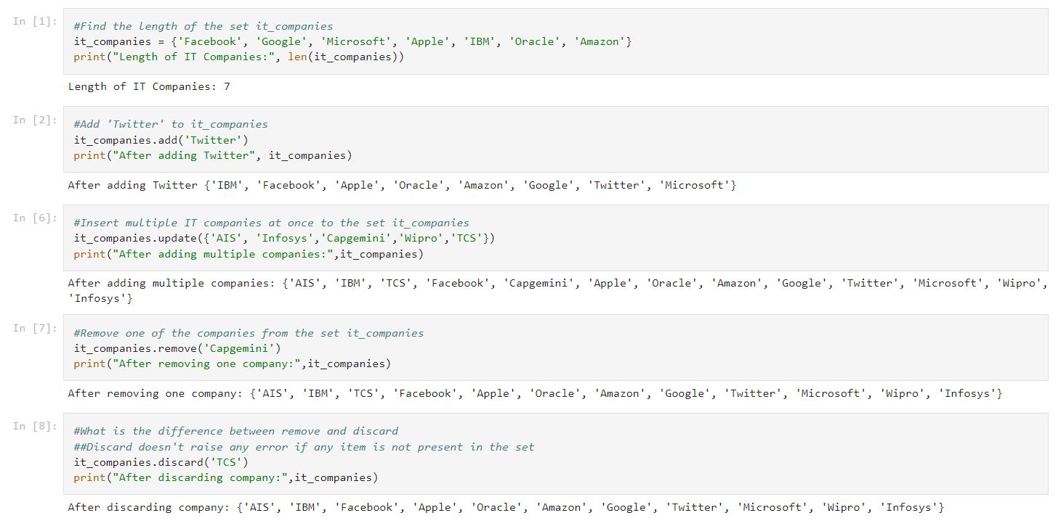

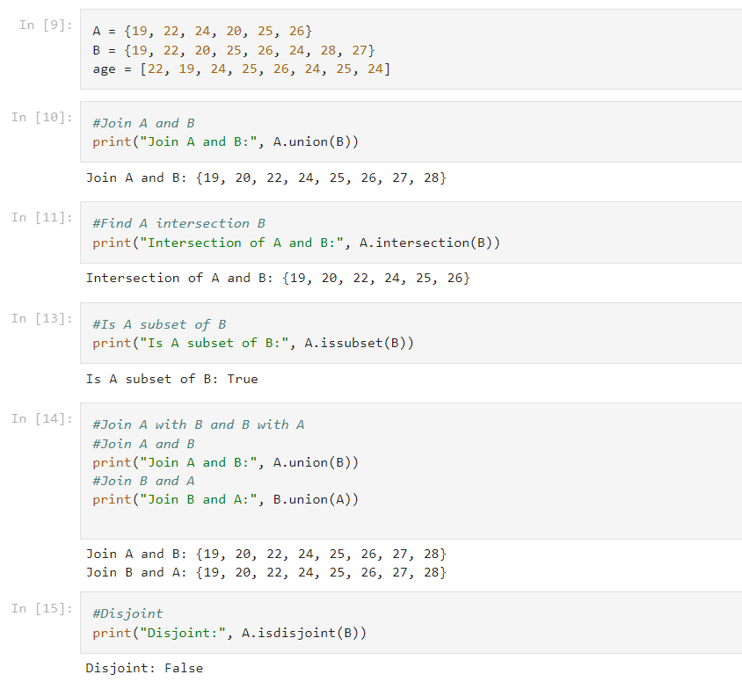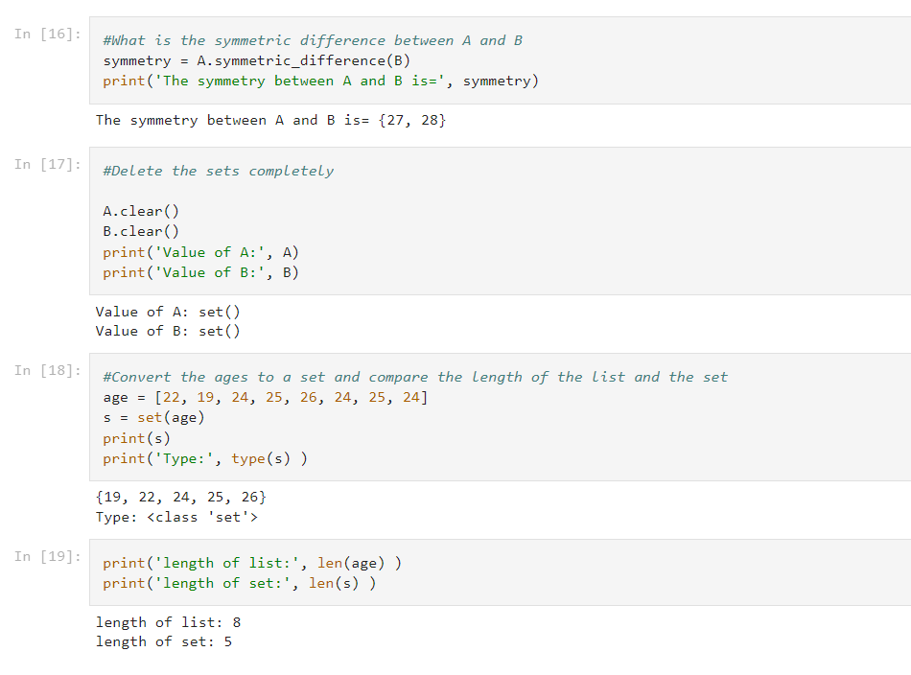

**Question 5**

The radius of a circle is 30 meters.

* Calculate the area of a circle and assign the value to a variable name of area_of_circle
* Calculate the circumference of a circle and assign the value to a variable name of circum_of_circle
* Take radius as user input and calculate the area.

#Calculate the area of a circle and assign the value to a variable name of area_of_circle

from math import pi

r = 30

print ("The area of the circle with radius " + str(r) + " is: " + str(pi * r**2))

#Calculate the circumference of a circle and assign the value to a variable name of circum_of_circle

print ("The circumference of the circle with radius " + str(r) + " is: " + str(2 * pi * r))

#Take radius as user input and calculate the area.

from math import pi

r = float(input ("Input the radius of the circle : "))

print ("The area of the circle with radius " + str(r) + " is: " + str(pi * r**2))

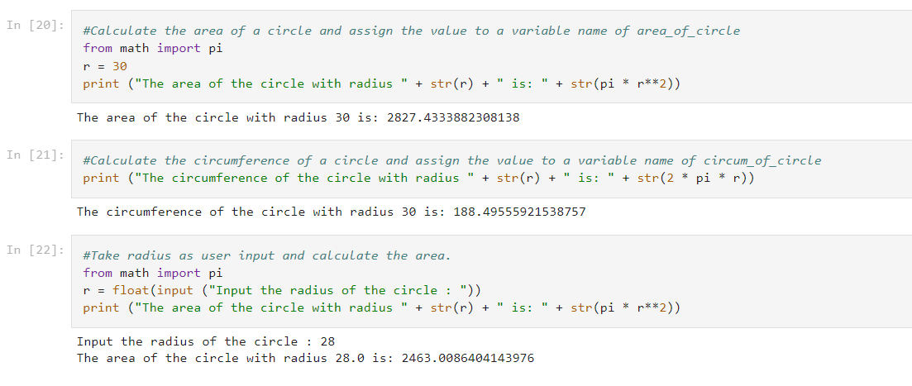

**Question 6**

“I am a teacher and I love to inspire and teach people”

* How many unique words have been used in the sentence? Use the split methods and set to get the unique words.

#Unique word

sentence = "I am a teacher and I love to inspire and teach people".split()

unique = [uniq for uniq in sentence if uniq not in sentence[sentence.index(uniq)+1:]]

print('Unique words:', unique)

print('Number of Unique words:', len(unique))

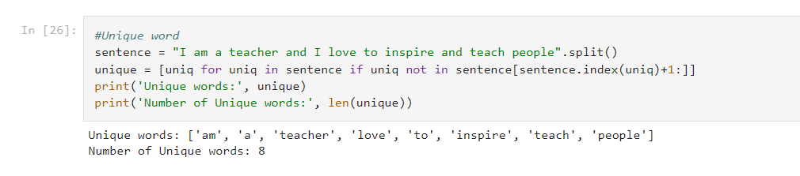

**Question 7**

Use a tab escape sequence to get the following lines.

Name Age Country City

Asabeneh 250 Finland Helsinki

lines= "Name\t Age\tCountry\tCity\t\nAsabeneh 250\tFinland\tHelsinki"

print(lines)

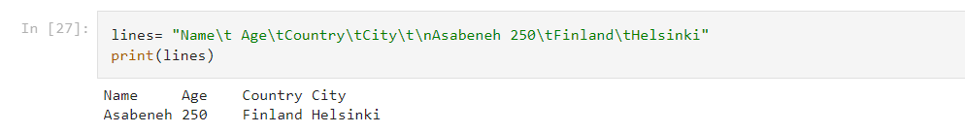

**Question 8**

* Use the string formatting method to display the following:

radius = 10

area = 3.14 * radius ** 2

“The area of a circle with radius 10 is 314 meters square.”

r=10

print(f'radius = 10')

print(f'area = 3.14*radius**2')

print(f'"The area of circle with radius {r} is {3.14*r*r} meters square"')

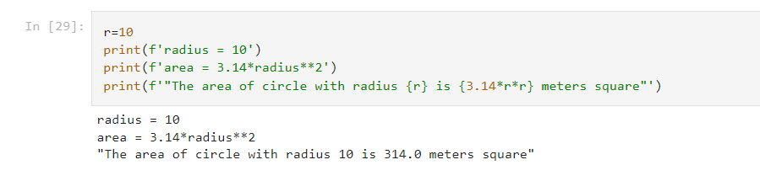

**Question 9**

* Write a program, which reads weights (lbs.) of N students into a list and convert these weights to kilograms in a separate list using Loop. N: No of students (Read input from user)

Ex: L1: [150, 155, 145, 148]

Output: [68.03, 70.3, 65.77, 67.13]

L1=[int(num) for num in input().split(" ")]

#Creating another list called Weight_kg

Weight_kg=[]

#Using for loop to iterate the values and appending the list

for i in L1:

Weight_kg.append(round(i/2.205,2))

#Displaying the values in kgs after conversion

print ("Values are:",Weight_kg)

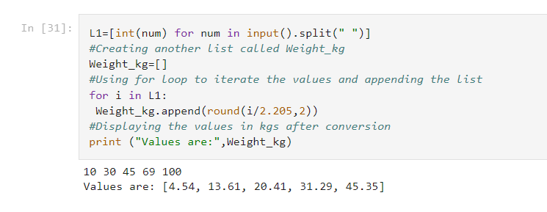

**Question 10**

The diagram below shows a dataset with 2 classes and 8 data points, each with only one feature value, labeled f. Note that there are two data points with the same feature value of 6. These are shown as two x’s one above the other. Provide stepwise mathematical solution, do not write code for it. 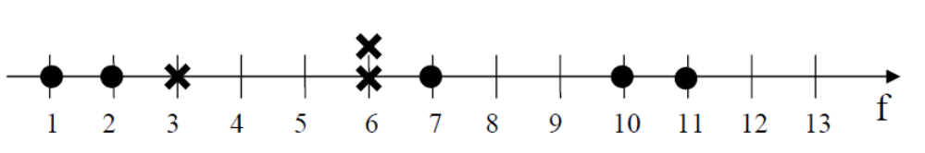

1. Divide this data equally into two parts. Use first part as training and second part as testing. Using KNN classifier, for K=3, what would be the predicted outputs for the test samples? Show how you arrived at your answer.
2. Compute the confusion matrix for this and calculate accuracy, sensitivity and specificity values.

